Problem 8-18:

Given Data:

|  |  |  |  |  |  |  |
| --- | --- | --- | --- | --- | --- | --- |
| **t** | 0.0 | 1.0 | 2.0 | 3.0 | 4.0 | 5.0 |
| **y** | 1.0 | 2.7 | 5.8 | 6.6 | 7.5 | 9.9 |

1. **Fitting a polynomial of degree n then taking the derivative, n=0, 1, …, 5**

**n = 0**

The polynomial: $y=5.583$

The derivative: $dy/dt=0$

The following table shows the derivative of the original data, derivative of original data perturbed by $±1\%$, and derivative of original data perturbed by $±5\%$

|  |  |  |  |  |  |  |
| --- | --- | --- | --- | --- | --- | --- |
| **t** | 0.0 | 1.0 | 2.0 | 3.0 | 4.0 | 5.0 |
| **dy/dt** | 0.0 | 0.0 | 0.0 | 0.0 | 0.0 | 0.0 |
| **dy/dt (1%)** | 0.0 | 0.0 | 0.0 | 0.0 | 0.0 | 0.0 |
| **Rel. Change (1%)** | 0.0 | 0.0 | 0.0 | 0.0 | 0.0 | 0.0 |
| **dy/dt (5%)** | 0.0 | 0.0 | 0.0 | 0.0 | 0.0 | 0.0 |
| **Rel. Change (5%)** | 0.0 | 0.0 | 0.0 | 0.0 | 0.0 | 0.0 |

The following comments can be made from the observation:

* The derivative values are all equal to zero and hence not plausible.
* The derivative estimate is not sensitive to the change in the data points.

**n = 1**

The polynomial: $y=1.319+1.706$

The derivative: $\frac{dy}{dt}=1.706$

The following table shows the derivative of the original data, derivative of original data perturbed by $±1\%$, and derivative of original data perturbed by $±5\%$

|  |  |  |  |  |  |  |
| --- | --- | --- | --- | --- | --- | --- |
| **t** | 0.0 | 1.0 | 2.0 | 3.0 | 4.0 | 5.0 |
| **dy/dt** | 1.706 | 1.706 | 1.706 | 1.706 | 1.706 | 1.706 |
| **dy/dt (1%)** | 1.695 | 1.695 | 1.695 | 1.695 | 1.695 | 1.695 |
| **Rel. Change (1%)** | 0.645 | 0.645 | 0.645 | 0.645 | 0.645 | 0.645 |
| **dy/dt (5%)** | 1.645 | 1.645 | 1.645 | 1.645 | 1.645 | 1.645 |
| **Rel. Change (5%)** | 3.576 | 3.576 | 3.576 | 3.576 | 3.576 | 3.576 |

The following comments can be made from the observation:

* The value of the derivatives is all positive, again not plausible.
* The derivative estimate is not sensitive,
* Also the relative changes in the derivative are constant and also bounded by the perturbation in the data.

**n = 2**

The polynomial: $y=1.004+2.179t^{ }-0.095t^{ 2}$

The derivative: $dy/dt=2.179-0.189t^{ }$

The following table shows the derivative of the original data, derivative of original data perturbed by $±1\%$, and derivative of original data perturbed by $±5\%$

|  |  |  |  |  |  |  |
| --- | --- | --- | --- | --- | --- | --- |
| **t** | 0.0 | 1.0 | 2.0 | 3.0 | 4.0 | 5.0 |
| **dy/dt** | 2.179 | 1.990 | 1.800 | 1.611 | 1.422 | 1.233 |
| **dy/dt (1%)** | 2.161 | 1.981 | 1.801 | 1.621 | 1.441 | 1.261 |
| **Rel. Change (1%)** | 0.823 | 0.434 | 0.036 | 0.616 | 1.351 | 2.312 |
| **dy/dt (5%)** | 2.028 | 1.932 | 1.836 | 1.740 | 1.644 | 1.548 |
| **Rel. Change (5%)** | 6.927 | 2.897 | 1.980 | 8.003 | 15.629 | 25.598 |

Comments:

* The derivative values are reasonable; they are all positive.
* The derivative estimate is senstive, relative change in derivative is much higher than relative change in data values, and it is growing.

**n = 3**

The polynomial: $y=0.790+3.156t^{ }-0.629t^{ 2}+0.071t^{ 3}$

The derivative: $dy/dt=3.156-1.259t+0.214t^{2}$

The following table shows the derivative of the original data, derivative of original data perturbed by $±1\%$, and derivative of original data perturbed by $±5\%$

|  |  |  |  |  |  |  |
| --- | --- | --- | --- | --- | --- | --- |
| **t** | 0.0 | 1.0 | 2.0 | 3.0 | 4.0 | 5.0 |
| **dy/dt** | 3.156 | 2.111 | 1.494 | 1.304 | 1.543 | 2.209 |
| **dy/dt (1%)** | 3.254 | 2.109 | 1.451 | 1.280 | 1.597 | 2.401 |
| **Rel. Change (1%)** | 3.115 | 0.087 | 2.864 | 1.878 | 3.500 | 8.679 |
| **dy/dt (5%)** | 3.400 | 2.158 | 1.461 | 1.308 | 1.699 | 2.635 |
| **Rel. Change (5%)** | 7.742 | 2.234 | 2.195 | 0.269 | 10.111 | 19.271 |

Comments:

* The derivative values are reasonable; they are all positive.
* The derivative estimate is senstive, relative change in derivative is much higher than relative change in data values, and it is growing.

**n = 4**

The polynomial: $y=0.972+0.120t^{ }+2.634t^{ 2}-0.991t^{ 3}+0.106t^{ 4}$

The derivative: $dy/dt=0.120+5.268t-2.974t^{2}+0.425t^{3}$

The following table shows the derivative of the original data, derivative of original data perturbed by $±1\%$, and derivative of original data perturbed by $±5\%$

|  |  |  |  |  |  |  |
| --- | --- | --- | --- | --- | --- | --- |
| **t** | 0.0 | 1.0 | 2.0 | 3.0 | 4.0 | 5.0 |
| **dy/dt** | 0.120 | 2.839 | 2.162 | 0.637 | 0.814 | 5.245 |
| **dy/dt (1%)** | 0.007 | 2.887 | 2.178 | 0.572 | 0.763 | 5.443 |
| **Rel. Change (1%)** | 94.155 | 1.682 | 0.750 | 10.151 | 6.353 | 3.773 |
| **dy/dt (5%)** | -0.341 | 2.886 | 2.284 | 0.691 | 0.945 | 5.882 |
| **Rel. Change (5%)** | 384.388 | 1.637 | 5.671 | 8.587 | 15.990 | 12.140 |

Comments:

* The derivative values are reasonable; they are all positive, when small perturbations are added, some values become negative.
* The derivative estimate is highly senstive, relative change in derivative is much higher than relative change in data values specially as t approaches zero.

**n = 5**

The polynomial: $y=1.0-3.178t^{ }+8.304t^{ 2}-4.213t^{ 3}+0.846t^{ 4}-0.059t^{ 5}$

The derivative: $dy/dt=-3.178+16.608t^{ }-12.638t^{ 2}+3.383t^{ 3}-0.296t^{ 4}$

The following table shows the derivative of the original data, derivative of original data perturbed by $±1\%$, and derivative of original data perturbed by $±5\%$

|  |  |  |  |  |  |  |
| --- | --- | --- | --- | --- | --- | --- |
| **t** | 0.0 | 1.0 | 2.0 | 3.0 | 4.0 | 5.0 |
| **dy/dt** | -3.178 | 3.880 | 1.822 | 0.297 | 1.855 | 1.947 |
| **dy/dt (1%)** | -3.404 | 3.994 | 1.770 | 0.283 | 1.985 | 1.414 |
| **Rel. Change (1%)** | 7.100 | 2.938 | 2.836 | 4.607 | 7.008 | 27.363 |
| **dy/dt (5%)** | -2.721 | 3.634 | 1.411 | 0.723 | 2.487 | -1.573 |
| **Rel. Change (5%)** | 14.389 | 6.340 | 22.543 | 143.708 | 34.070 | 180.805 |

Comments:

* The derivative values are not reasonable; some values are negative.
* The derivative estimate is senstive, relative change in derivative is much higher than relative change in data points is 0.

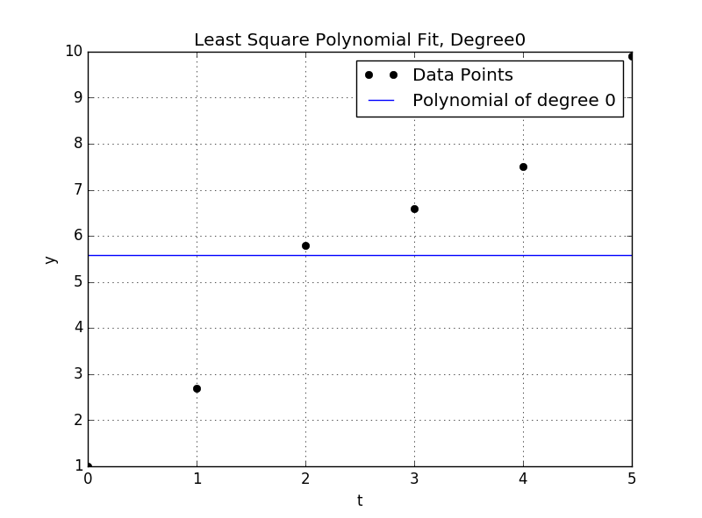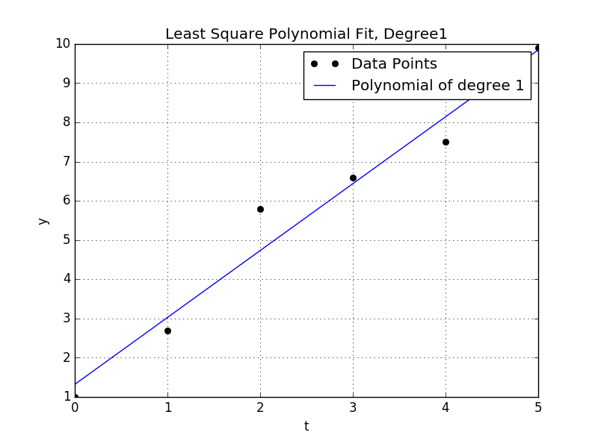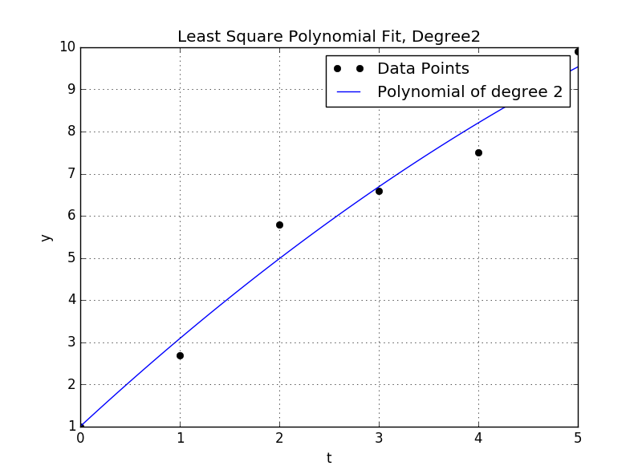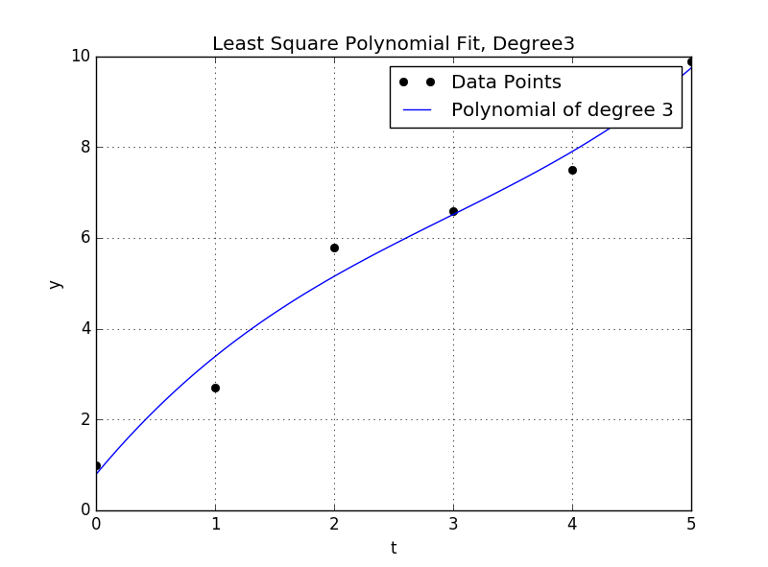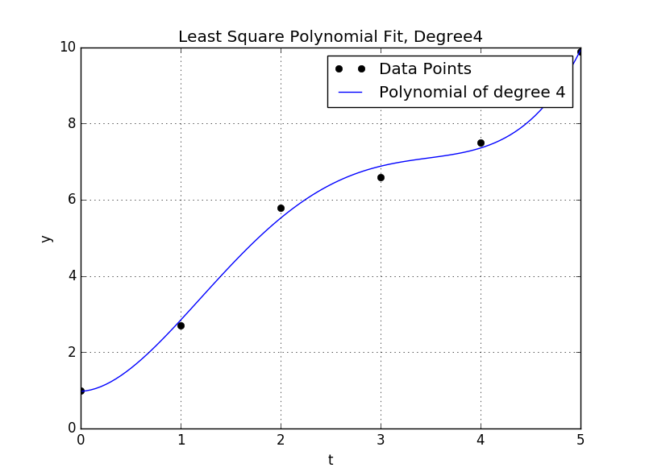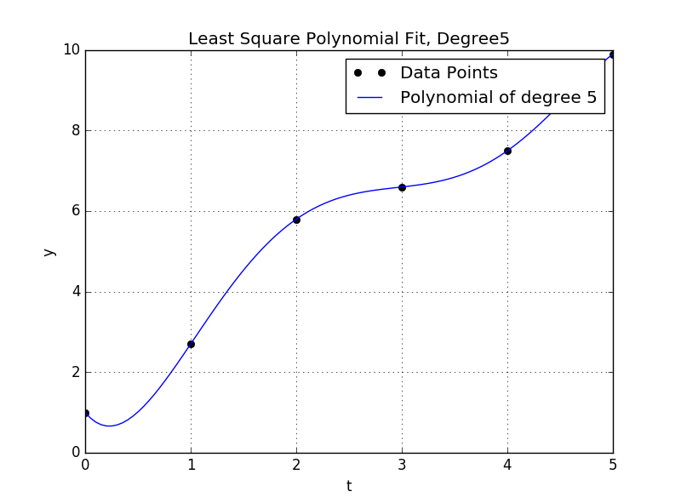

**Conclusion:**

* The derivatives are reasonable when n is small but not zero, i.e. no much fluctuations in the curve.
* For small n, the solutions also tend to be more stable.
* For high values of n, values of derivative started to be unreasonable due to fluctuations in the curve that caused some negative values.
* Also the solutions started to be more unstable.

1. **Using cubic spline:**

Using *scipy.interpolate.UnivariateSpline* with k=3 and getting the derivative directly from the routine, the following results are produced.

|  |  |  |  |  |  |  |
| --- | --- | --- | --- | --- | --- | --- |
| t | 0.0 | 1.0 | 2.0 | 3.0 | 4.0 | 5.0 |
| dy/dt | -0.765 | 3.285 | 2.006 | 0.397 | 1.516 | 3.421 |
| dy/dt (1%) | -0.554 | 3.180 | 2.013 | 0.395 | 1.467 | 3.916 |
| Rel. Change (1%) | 27.608 | 3.208 | 0.321 | 0.493 | 3.234 | 14.479 |
| dy/dt (5%) | 0.245 | 2.770 | 2.364 | 0.440 | 0.732 | 5.558 |
| Rel. Change (5%) | 132.029 | 15.677 | 17.822 | 10.729 | 51.714 | 62.478 |

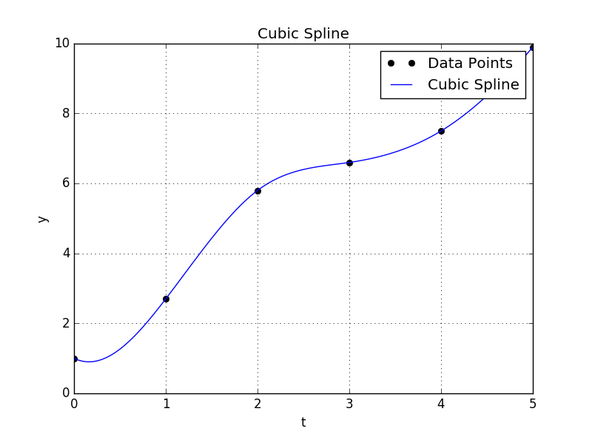

Comments:

* The derivative values are not reasonable; some values are negative.
* The derivative estimate is highly sensitive to any change in the input data.

1. **Using cubic spline:**

Using *scipy.interpolate.UnivariateSpline* with different values of smoothing values, and getting the derivative directly from the routine, the following results are produced.

**k = 1**

|  |  |  |  |  |  |  |
| --- | --- | --- | --- | --- | --- | --- |
| t | 0.0 | 1.0 | 2.0 | 3.0 | 4.0 | 5.0 |
| dy/dt | 1.707 | 3.087 | 0.808 | 0.902 | 2.395 | 2.395 |
| dy/dt (1%) | 1.717 | 3.029 | 0.801 | 0.968 | 2.296 | 2.296 |
| Rel. Change (1%) | 0.584 | 1.883 | 0.930 | 7.237 | 4.113 | 4.113 |
| dy/dt (5%) | 1.756 | 2.801 | 1.421 | 0.579 | 2.391 | 2.391 |
| Rel. Change (5%) | 2.870 | 9.276 | 75.874 | 35.786 | 0.161 | 0.161 |

**k = 2**

|  |  |  |  |  |  |  |
| --- | --- | --- | --- | --- | --- | --- |
| t | 0.0 | 1.0 | 2.0 | 3.0 | 4.0 | 5.0 |
| dy/dt | 0.671 | 2.742 | 2.053 | 0.534 | 1.569 | 3.232 |
| dy/dt (1%) | 0.724 | 2.709 | 2.008 | 0.579 | 1.573 | 3.031 |
| Rel. Change (1%) | 7.867 | 1.209 | 2.232 | 8.518 | 0.247 | 6.228 |
| dy/dt (5%) | 1.029 | 2.487 | 2.276 | 0.742 | 1.271 | 3.516 |
| Rel. Change (5%) | 53.289 | 9.298 | 10.849 | 39.040 | 19.034 | 8.778 |

**k = 4**

|  |  |  |  |  |  |  |
| --- | --- | --- | --- | --- | --- | --- |
| t | 0.0 | 1.0 | 2.0 | 3.0 | 4.0 | 5.0 |
| dy/dt | -2.287 | 3.698 | 1.877 | 0.352 | 1.673 | 2.838 |
| dy/dt (1%) | -2.194 | 3.651 | 1.828 | 0.394 | 1.723 | 2.497 |
| Rel. Change (1%) | 4.063 | 1.268 | 2.627 | 12.057 | 2.979 | 12.010 |
| dy/dt (5%) | -0.359 | 2.941 | 2.258 | 0.711 | 0.863 | 4.728 |
| Rel. Change (5%) | 84.303 | 20.478 | 20.305 | 101.872 | 48.398 | 66.627 |

**k = 5**

|  |  |  |  |  |  |  |
| --- | --- | --- | --- | --- | --- | --- |
| t | 0.0 | 1.0 | 2.0 | 3.0 | 4.0 | 5.0 |
| dy/dt | -3.178 | 3.880 | 1.822 | 0.297 | 1.855 | 1.947 |
| dy/dt (1%) | -3.105 | 3.837 | 1.771 | 0.338 | 1.909 | 1.586 |
| Rel. Change (1%) | 2.297 | 1.110 | 2.770 | 13.916 | 2.895 | 18.530 |
| dy/dt (5%) | -0.514 | 2.980 | 2.246 | 0.698 | 0.903 | 4.573 |
| Rel. Change (5%) | 83.823 | 23.196 | 23.285 | 135.393 | 51.348 | 134.932 |

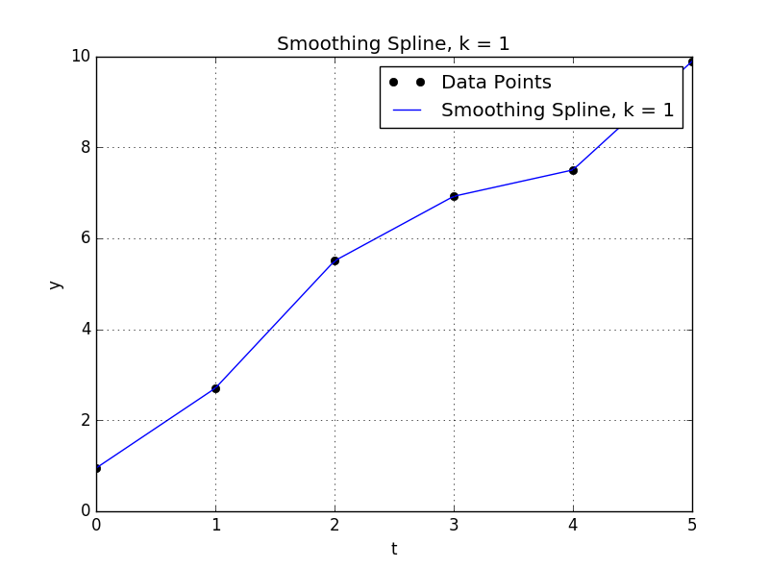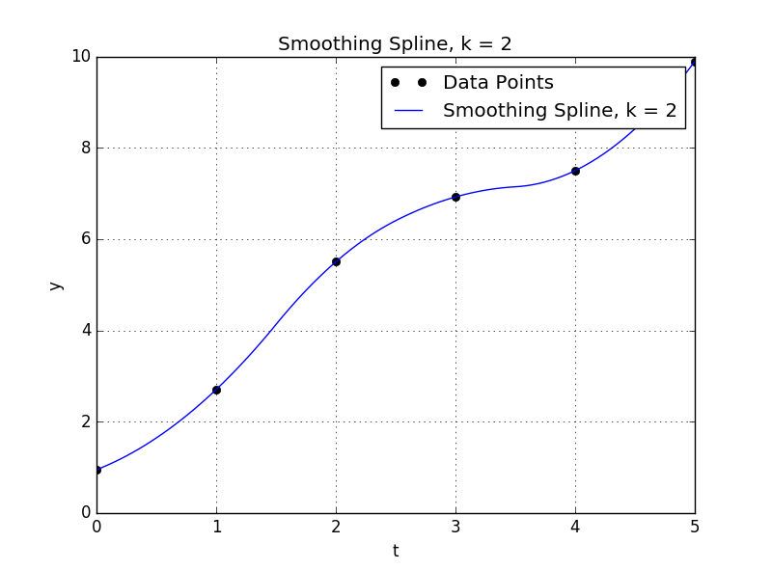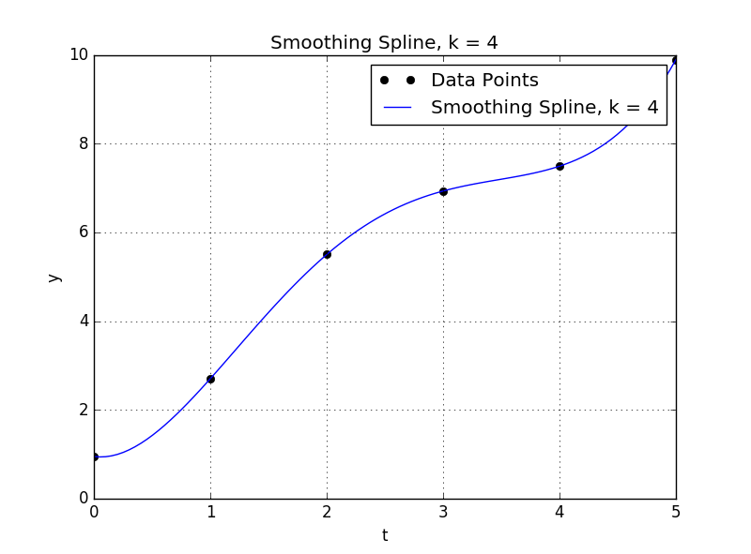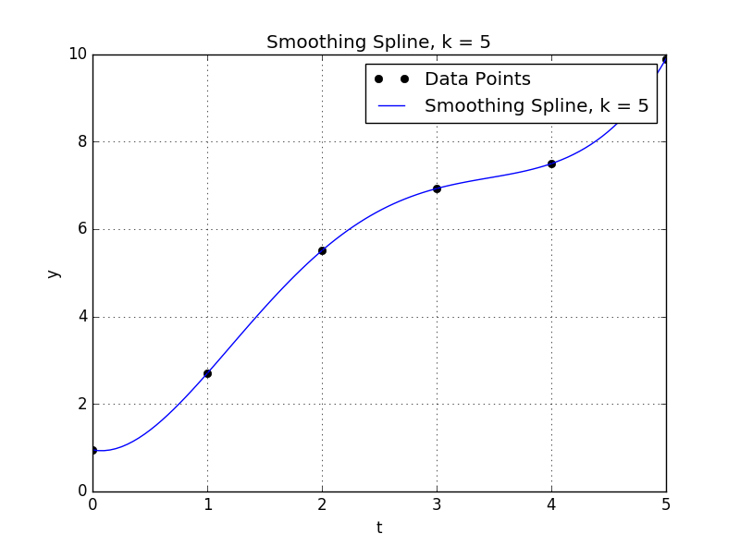

Comments:

* The derivative values are reasonable for k=1,k=2, but not reasonable for k=4,k=5.
* This observation verifies the discussed effect of higher order interpolation in   
  part (a).
* For k=1, k=2 , method isn’t highly sensitive to perturbations, but for k=4, k=5 it is highly sensitive.

1. **Using monotonic Hermit spline:**

Using *scipy.* *interpolate.PchipInterpolator* to get the derivative directly from the routine, the following results are produced.

|  |  |  |  |  |  |  |
| --- | --- | --- | --- | --- | --- | --- |
| t | 0.0 | 1.0 | 2.0 | 3.0 | 4.0 | 5.0 |
| dy/dt | 1.000 | 2.196 | 1.272 | 0.847 | 1.309 | 3.150 |
| dy/dt (1%) | 0.956 | 2.202 | 1.202 | 0.843 | 1.374 | 3.000 |
| Rel. Change (1%) | 4.400 | 0.269 | 5.515 | 0.516 | 4.948 | 4.762 |
| dy/dt (5%) | 1.200 | 2.387 | 0.341 | 0.324 | 1.567 | 1.493 |
| Rel. Change (5%) | 20.000 | 8.725 | 73.177 | 61.786 | 19.671 | 52.619 |

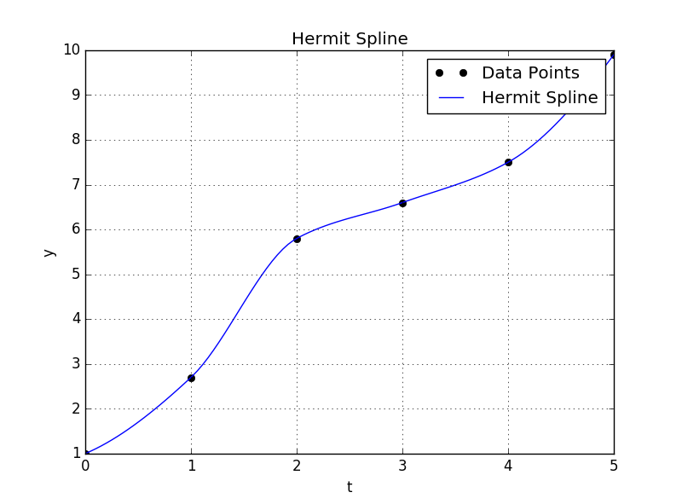

Comments:

* The derivative values are reasonable; all values are positive.
* The derivative values are sensitive to any perturbation in the input data.